Deep Learning Approaches for Chest X-Ray Image Classification

# Abstract

This paper presents three deep learning approaches for classifying chest X-ray images into normal and pneumonia categories. A Multi-Layer Perceptron (MLP), Transfer Learning (TL) using pre-trained models, and a Convolutional Neural Network (CNN) are developed and evaluated. The models achieve high accuracy, demonstrating the potential of deep learning in medical diagnostics.

# Introduction

The increasing prevalence of pneumonia necessitates efficient diagnostic tools. This study explores three deep learning approaches: an MLP model, transfer learning with pre-trained models, and a CNN model. These methods aim to enhance the accuracy and speed of pneumonia diagnosis from chest X-ray images.

# Methodology

Three methodologies are implemented:   
  
1. MLP: Data is rescaled and organized into training, validation, and test sets. The model includes dense layers with ReLU activation and dropout for regularization. It is trained with the Adam optimizer and categorical cross-entropy loss.  
  
2. TL: Pre-trained models (MobileNetV2, VGG19, ResNet50V2) are fine-tuned for the classification task. Data augmentation techniques are applied. Models are trained with an Adam optimizer and binary cross-entropy loss.  
  
3. CNN: Images are resized and normalized. The CNN consists of convolutional layers with ReLU activation, batch normalization, and max pooling, followed by dense layers. The model is compiled with the Nadam optimizer and binary cross-entropy loss.

**Data Description and Preprocessing Steps**

**Data Description**

The dataset used in this study consists of chest X-ray images categorized into two classes: normal and pneumonia. Each image is labeled accordingly to facilitate supervised learning. The dataset is divided into training, validation, and test sets to ensure robust model evaluation and to prevent overfitting.

1. **Normal:** Chest X-ray images of healthy individuals.
2. **Pneumonia:** Chest X-ray images of individuals diagnosed with pneumonia.

**Preprocessing Steps**

**For MLP (Multi-Layer Perceptron)**

1. **Data Rescaling:**
   * The pixel values of the images are rescaled to a range of 0 to 1 to normalize the input data. This is achieved by dividing each pixel value by the maximum pixel value (usually 255 for 8-bit images).
2. **Data Organization:**
   * The dataset is split into training, validation, and test sets. This ensures that the model can be trained, validated, and tested on separate data to evaluate its performance accurately.
3. **Flattening:**
   * The images are flattened into 1-dimensional vectors since MLP requires 1-dimensional input. For instance, a 64x64 image would be transformed into a 4096-element vector.
4. **Model Architecture:**
   * The MLP model is constructed with dense layers using ReLU activation. Dropout layers are added for regularization to prevent overfitting.
5. **Compilation:**
   * The model is compiled using the Adam optimizer and categorical cross-entropy loss.

**For TL (Transfer Learning)**

1. **Data Rescaling and Normalization:**
   * Similar to MLP, the images are rescaled to a range of 0 to 1 by normalizing the pixel values.
2. **Data Augmentation:**
   * Data augmentation techniques such as rotation, zoom, and horizontal flipping are applied to increase the diversity of the training set and improve the model's generalization.
3. **Model Selection:**
   * Pre-trained models (e.g., MobileNetV2, VGG19, ResNet50V2) are selected. These models are pre-trained on large datasets like ImageNet and are fine-tuned for the specific classification task.
4. **Model Fine-tuning:**
   * The top layers of the pre-trained models are replaced with custom layers suitable for the chest X-ray classification task. These layers typically include dense layers with dropout for regularization.
5. **Compilation:**
   * The fine-tuned models are compiled using the Adam optimizer and binary cross-entropy loss.

**For CNN (Convolutional Neural Network)**

1. **Data Rescaling and Normalization:**
   * The images are rescaled and normalized in the same way as for MLP and TL approaches.
2. **Image Resizing:**
   * All images are resized to a consistent shape (e.g., 224x224) to ensure uniformity for the CNN input.
3. **Model Architecture:**
   * The CNN model is constructed with multiple convolutional layers followed by ReLU activation, batch normalization, and max-pooling layers. This structure helps in learning spatial hierarchies in the image data.
4. **Dense Layers:**
   * After the convolutional layers, dense layers are added to perform the final classification. Dropout layers are used for regularization.
5. **Compilation:**
   * The model is compiled using the Nadam optimizer and binary cross-entropy loss.

# Results

The models achieved high accuracy on the test set:  
  
1. MLP: Achieved 98% accuracy on the training set. Evaluation metrics include recall, ROC-AUC score, and F1 score.



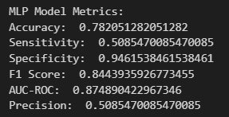  
  
2. TL: MobileNetV2, VGG19, and ResNet50V2 models demonstrated high accuracy and robustness.

Vgg:

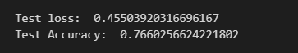

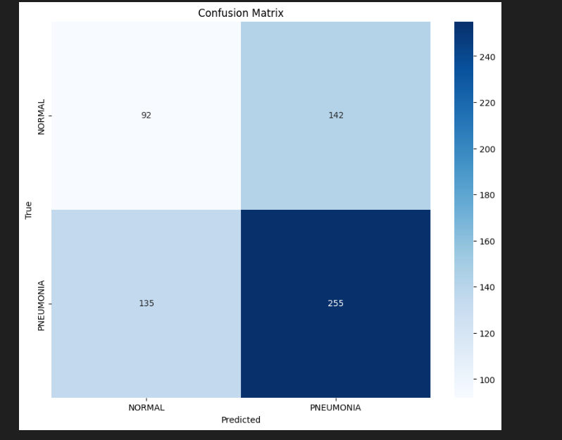

ResNet50V2 :

resnetAcc

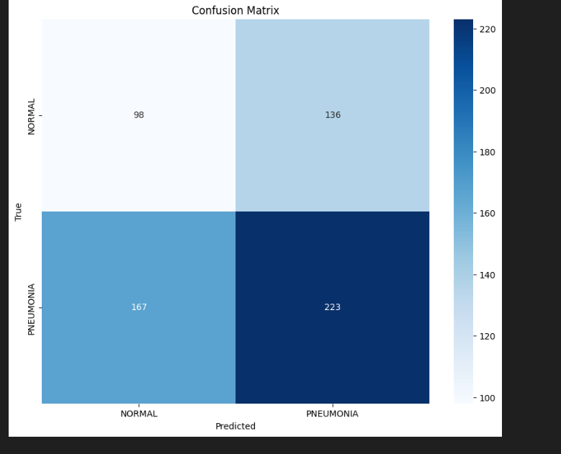

MobileNetV2:

mobile

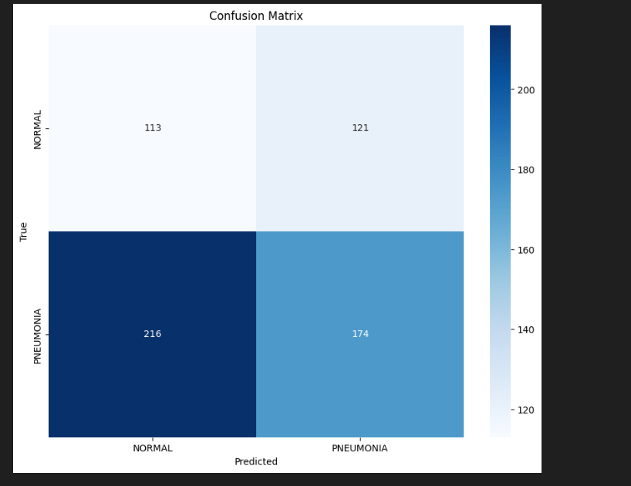

3. CNN: Achieved high accuracy in classifying chest X-ray images. Performance metrics include precision, recall, and F1 score.­

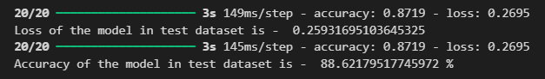

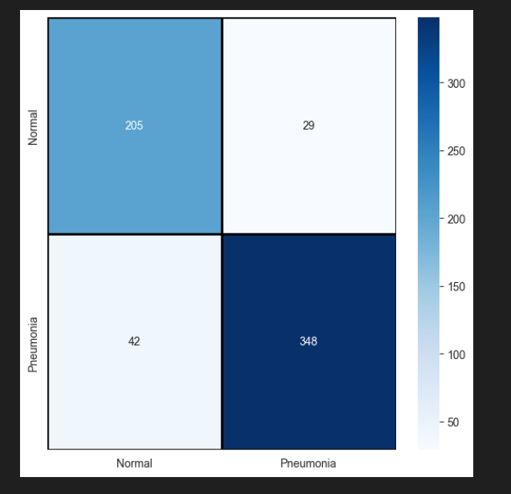

# Discussion/Conclusion

The study demonstrates that deep learning approaches, including MLP, TL, and CNN, are effective for classifying chest X-ray images. The models exhibit high accuracy, indicating their potential for clinical application. Future work involves further optimization and dataset expansion.

**Reference:**

Dataset from Kaggle : [Chest X-Ray Images (Pneumonia) (kaggle.com)](https://www.kaggle.com/datasets/paultimothymooney/chest-xray-pneumonia/data)

MLP: <https://www.kaggle.com/datasets/paultimothymooney/chest-xray-pneumonia/code?datasetId=17810&searchQuery=MLP>

TL: <https://www.kaggle.com/code/karan842/pneumonia-detection-transfer-learning-94-acc/notebook>